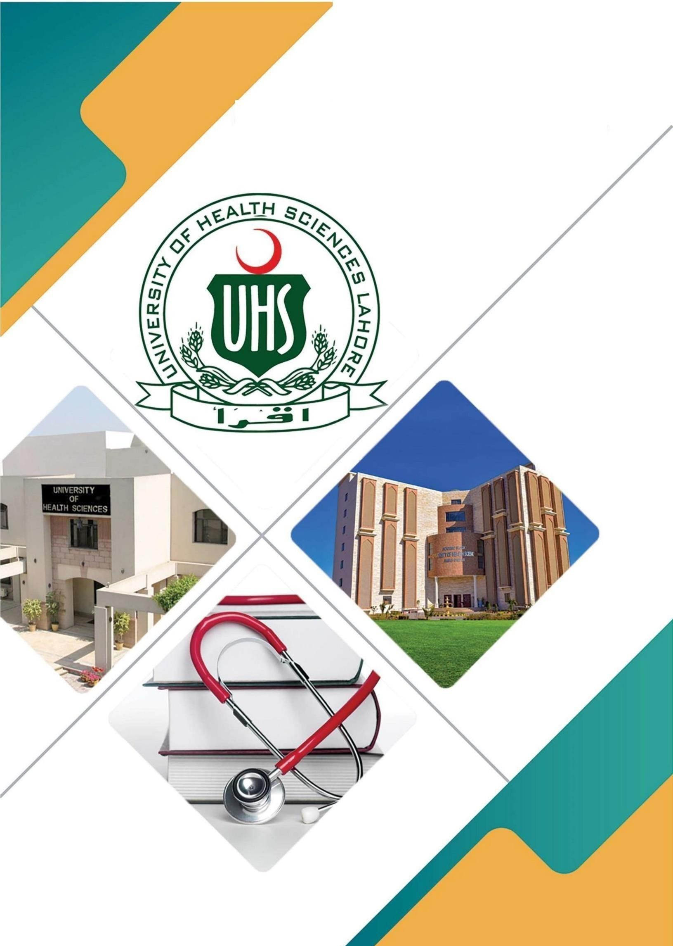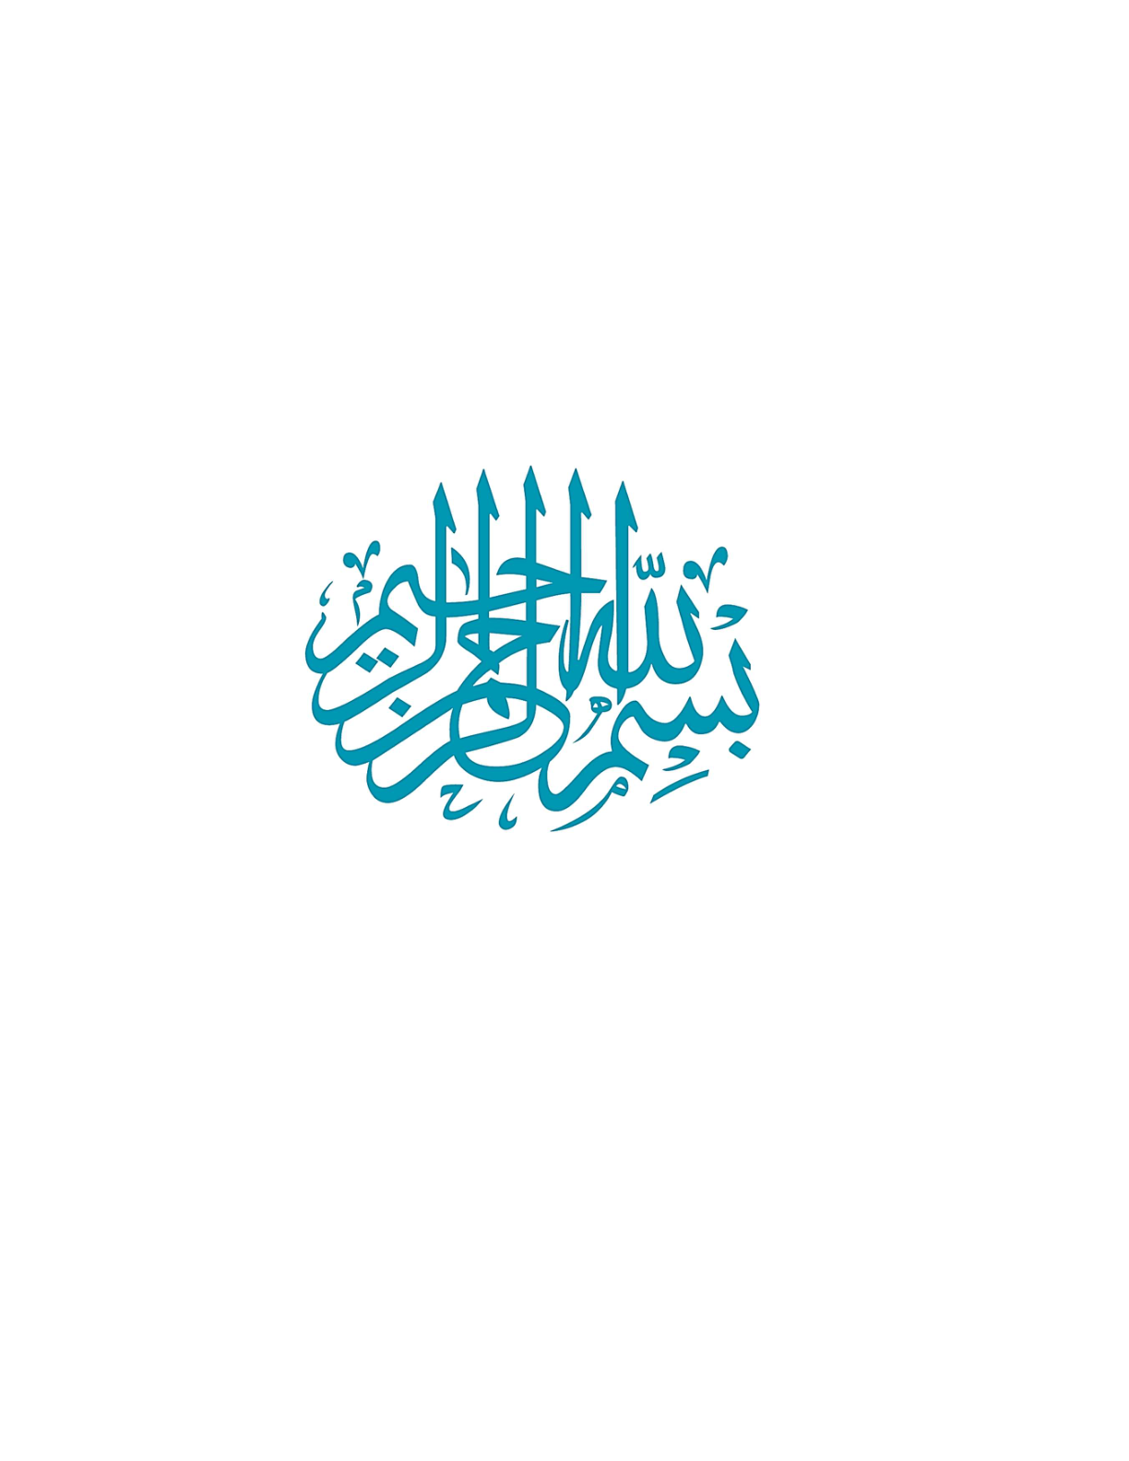

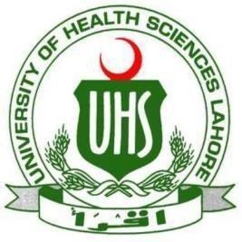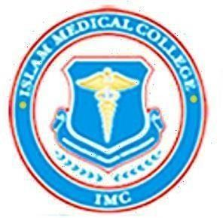

Block 9
Study Guide 2025
3rd Year MBBS
ISLAM MEDICAL COLLEGE
Sialkot–Pakistan

Block-9
CARIOVASCULAR =II
RESPIRATORY = II
COMMUNITY MEDICINE & FAMILY
HEALTH -I
FORENSIC MEDICINE & TOXICOLOGY -III
STUDY GUIDE

BLOCK LEAD DETAILS

Hello, I am Dr. Gul Maria working an Professor in the Department of Forensic Medicine & toxicology at Islam Medical College, Sialkot and now acting as a Block-9 Lead. I completed my MBBS from Baqai Medical University in 2004 and DMJ Forensic Medicine in 2016 from university of health sciences, Lahore. You can come to meet me in Forensic Medicine Department, Academic Block 1 from08:00 –15:00 hours on weekdays. You can also contact me freely on my email dr.mariagul786@gmail.com

MODULE OVERVIE

The Cardiovascular System (CVS 2) Module is designed to provide a understanding of cardiovascular diseases (CVDs), which are a leading cause of global morbidity and mortality. This module is critical at this stage of medical education as it integrates foundational knowledge from basic sciences—such as anatomy, physiology, and pathology—with clinical application in general medicine, surgery, cardiology, pharmacology, and vascular surgery. The module emphasizes the pathophysiology, clinical manifestations, diagnostic approaches, and management strategies for common and critical cardiovascular conditions, including coronary artery disease, valvular heart disease, aneurysms, cardiomyopathies, congenital heart diseases, and vascular disorders.

MODULE OUTCOMES
• Explain the underlying pathophysiological mechanisms of cardiovascular diseases and correlate them with clinical signs and symptoms
• Apply concepts from general medicine, surgery, cardiology, pharmacology, pathology, and vascular surgery to understand and manage cardiovascular diseases.
• Recognize and diagnose common and critical cardiovascular disorders using clinical features, physical examination, and diagnostic tools such as ECG, echocardiography, and laboratory investigations.
• Develop comprehensive, evidence-based management strategies, including medical, pharmacological, and surgical interventions, for treating cardiovascular diseases.
• Competently interpret diagnostic studies (e.g., ECG, echocardiography, and imaging) and use them to guide patient care decisions.
• Understand the role of various pharmacological agents in the prevention, treatment, and management
of cardiovascular conditions and complications
RESPIRATORY
The curriculum for respiratory medicine and related fields is designed to equip students with essential knowledge and skills in managing thoracic trauma, respiratory complications, and conditions affecting respiration.
Demonstrate the qualities of compassion, honesty, and integrity in interactions with patients, families, communities, and fellow medical professionals. Exhibit a professional demeanor, foster a team-oriented spirit, and employ effective communication skills by actively participating in collaborative problem-solving, particularly in small group exercises focused on understanding respiratory disorders.
MODULE OUTCOMES
• Integrate foundational concepts to address clinical respiratory issues.
• Interpret common respiratory symptoms with accuracy in assessments.
• Outline management plans for prevalent respiratory diseases during case discussions. • Utilize a problem-solving approach to accurately diagnose respiratory emergencies in simulated scenarios.
• Demonstrate understanding of respiratory tract malignancies and referral criteria by the end of the module.
• Identify the morphological features of common respiratory tract diseases in practical examinations.
• Demonstrate effective communication strategies in patient interactions, evaluated through peer and instructor feedback.

COMMUNITY MEDICINE & FAMILY HEALTH-I
The module on Community Medicine and Family Medicine is crucial for addressing the learning needs of medical students about holistic concept of health, prevalent health problems, their determinants and provision of comprehensive healthcare to the communities.
Curriculum on Community Medicine and family medicine equips future healthcare professionals with the knowledge, skills and attitude to implement preventive strategies, health promotion & reduce the burden of disease through primary health care approach targeting universal health coverage. Health outcomes are influenced by social, economic & environmental factors. It helps students understand the broader determinants of health & how to address health disparities. Public health crises such as pandemics, natural disasters & environmental hazards require professionals trained in community-based responses & health emergencies and reaching at door step through provision of family health services. Healthcare professionals must be equipped to engage in provision of health care needs at smaller scale and building health policy at local, national and global levels to improve public health outcomes.

MODULE OUTCOMES
To apply principles of epidemiological study designs in research methodology to establish association and causations
• To apply principles of community diagnosis, screening in general population and high-risk population
• To apply the concept of environmental safety and global environmental concerns including air, water, waste disposal, radiation, noise and climate change
• To apply principles of infectious disease epidemiology in classification, prevention and control of communicable diseases
• To apply different types of surveillance in disease control, elimination and eradication • To understand the concept of herd immunity and role of immunizing agents in disease prevention and control
• To demonstrate the difference between health education and propaganda, application of different health education, communication, information in different settings using different techniques and approaches
• To apply principles of primary health care targeting universal health care coverage through family medicine.
• To demonstrate comprehensive health care services as a concept of One Health which is attainable and achievable.

FORENSIC MEDICINE & TOXICOLOGY -III
This module prepares the 3rd year MBBS students for the real-world challenges of crime scene investigation, medico-legal frameworks of Pakistan, and dealing with cases of poisoning. This module is critical in developing a holistic understanding of the intersection of the medical profession and law.
MODULE OUTCOMES
• Describe different types of Laws
• Define legal terms relevant to medical practice and explain procedures in the courts of law
• Explain legal aspects of medical practice
• Discuss the principles and methods of crime scene investigations
• Describe different analytical techniques to diagnose the nature of poison/drugs

Block weeks = 9.44
Recommended minimum hours = 17+101+115 +40 =273

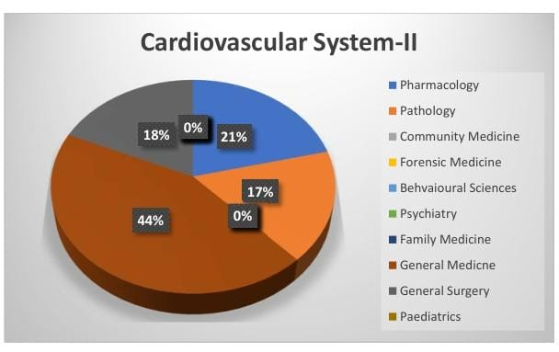
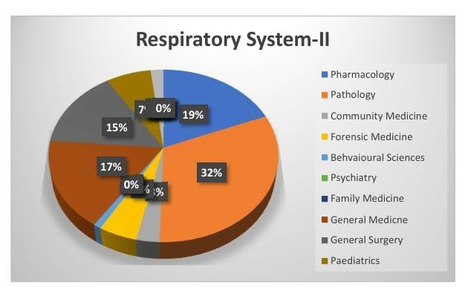

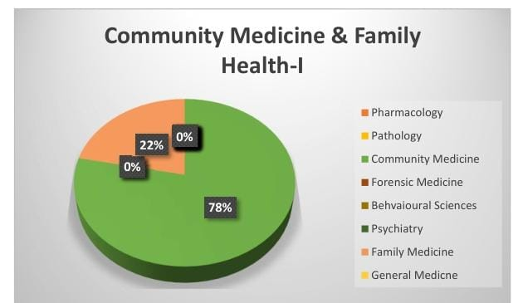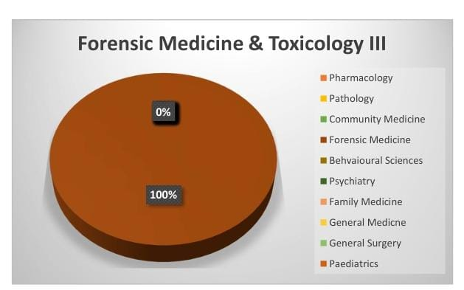
Cardiovascular System -II Module Content

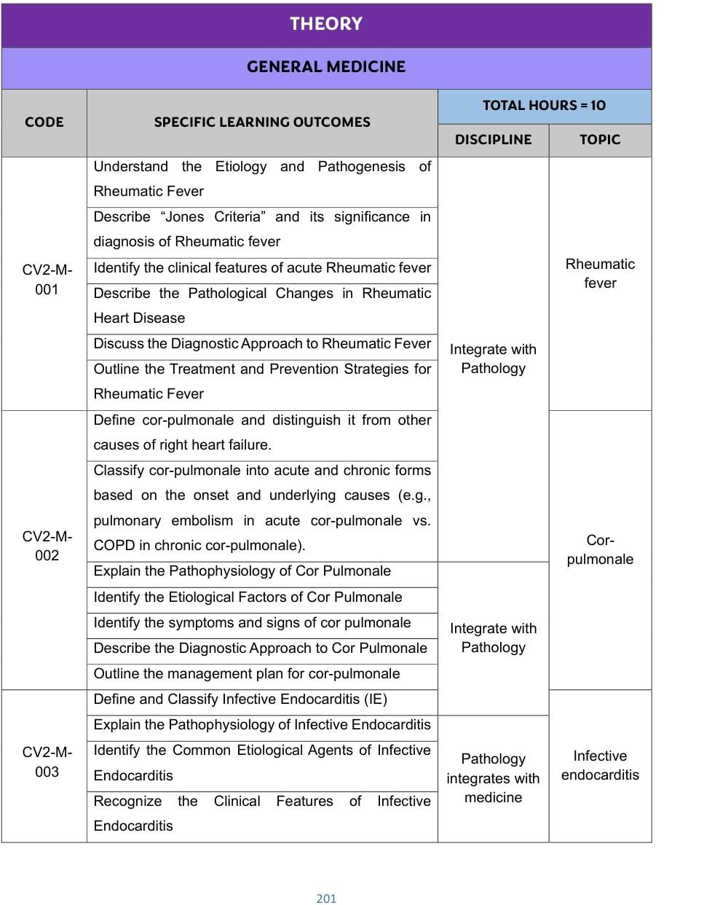
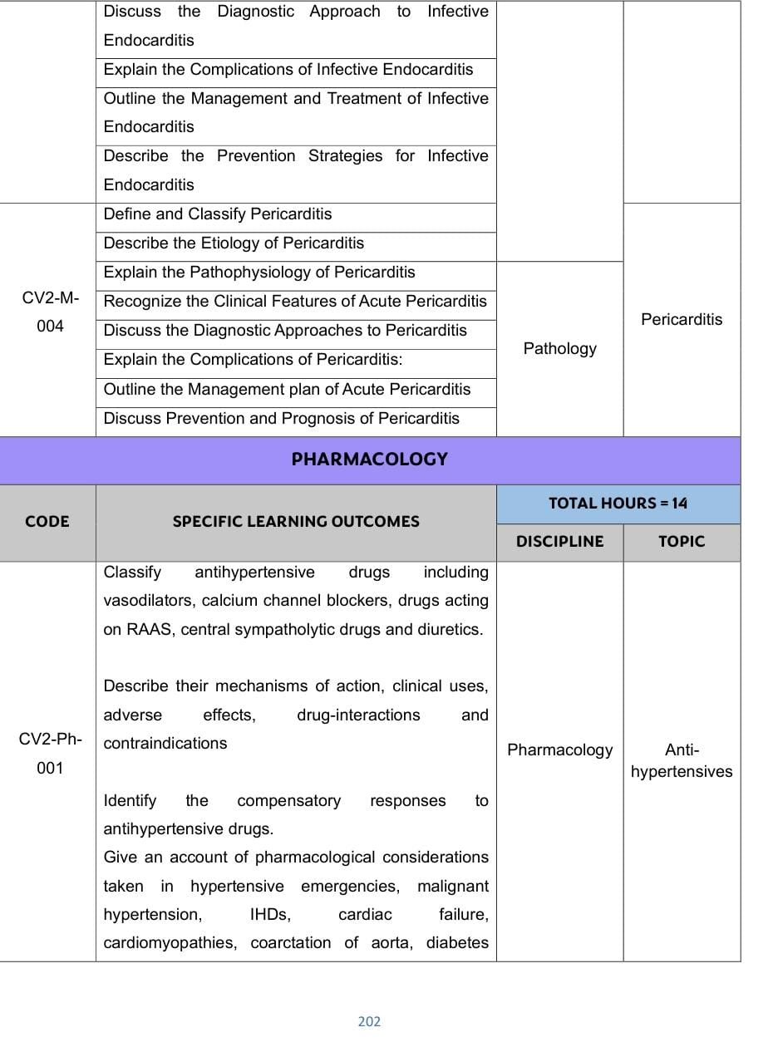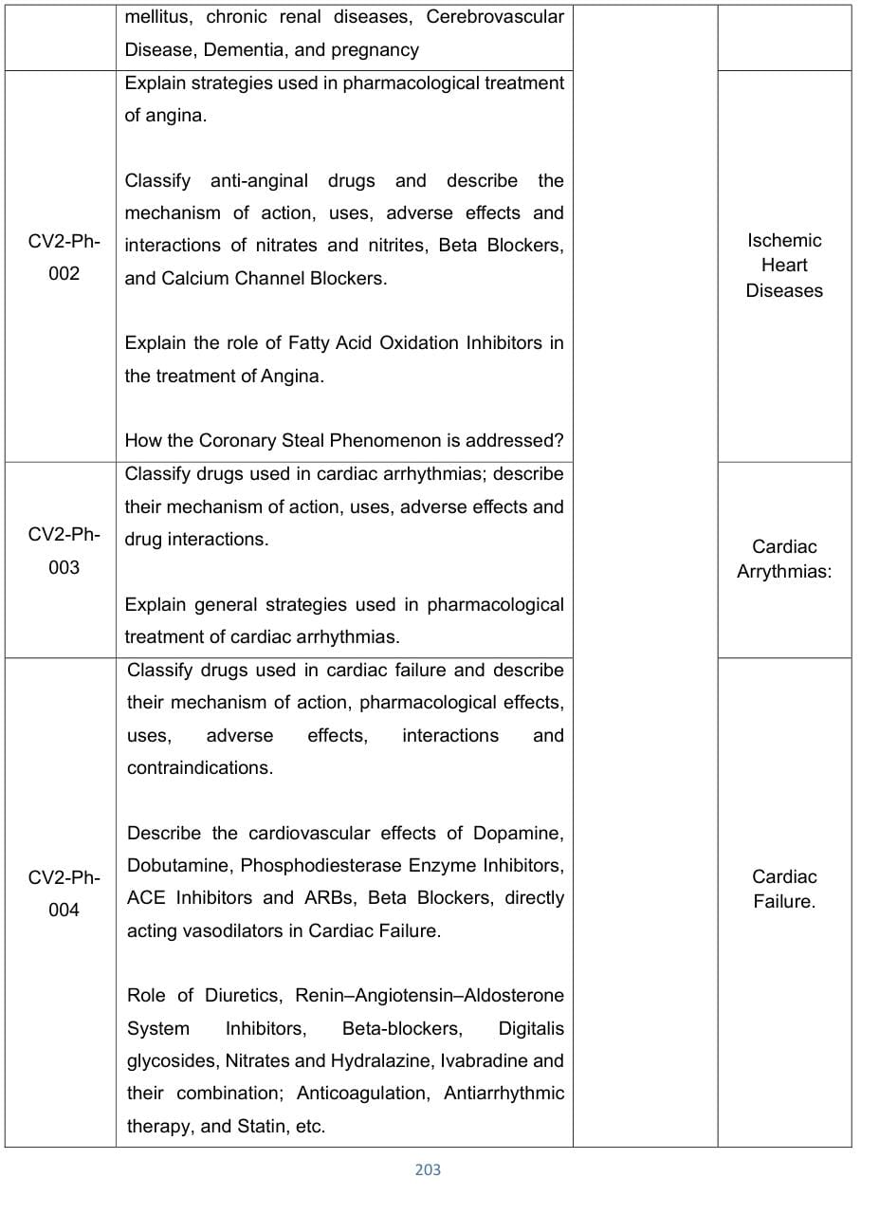
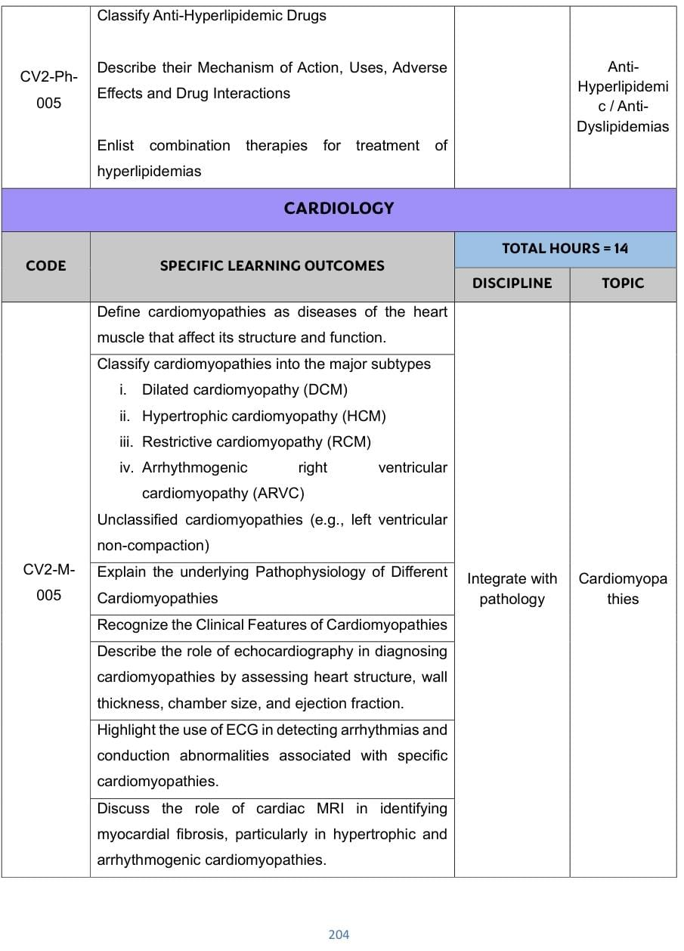
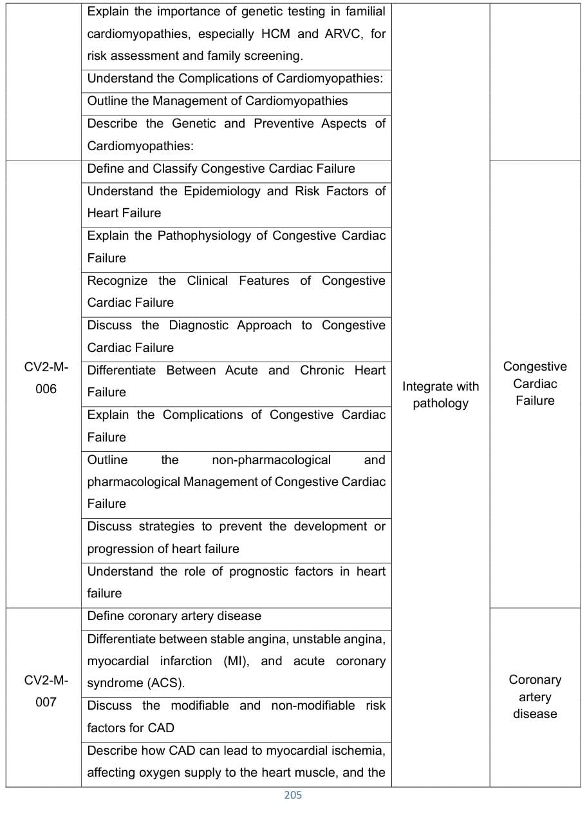
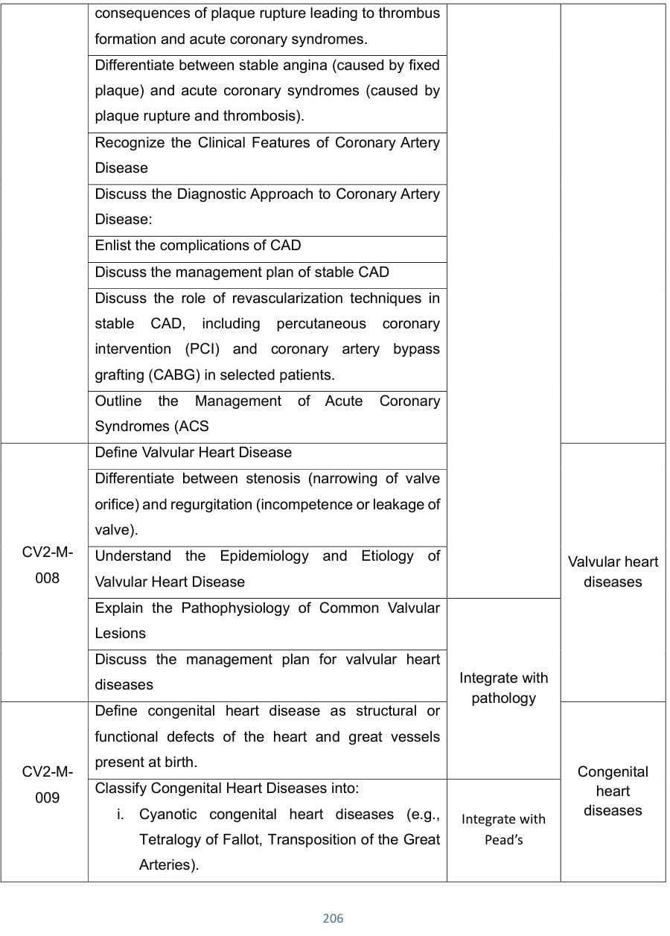
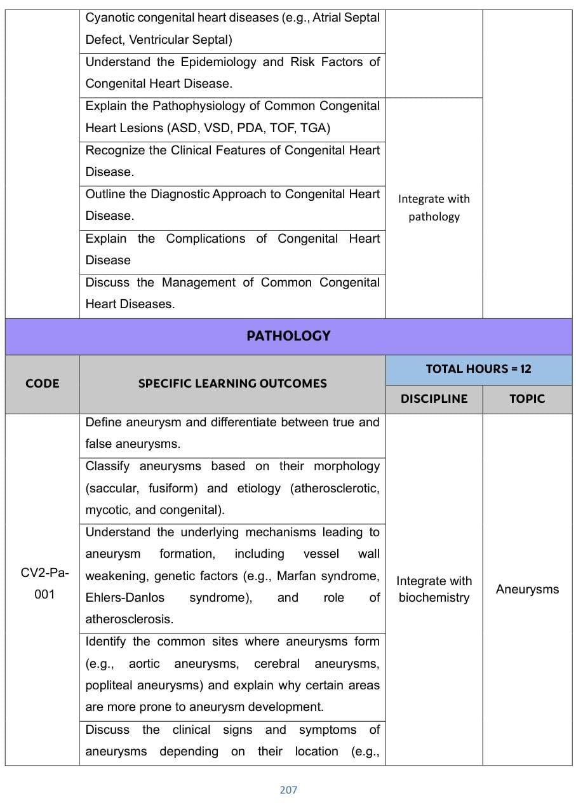
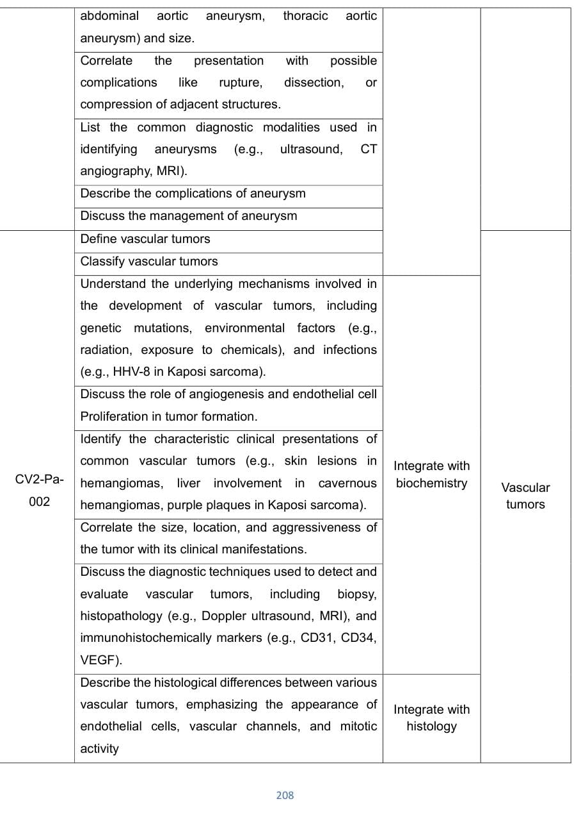
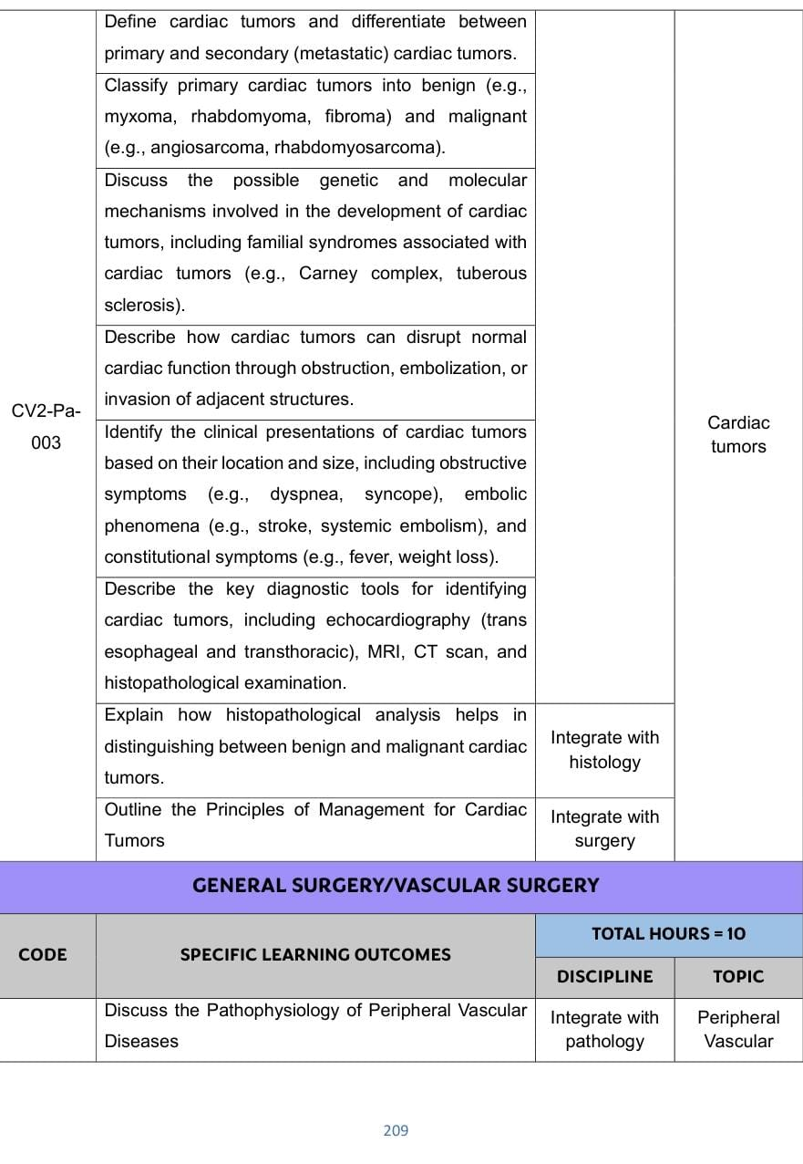
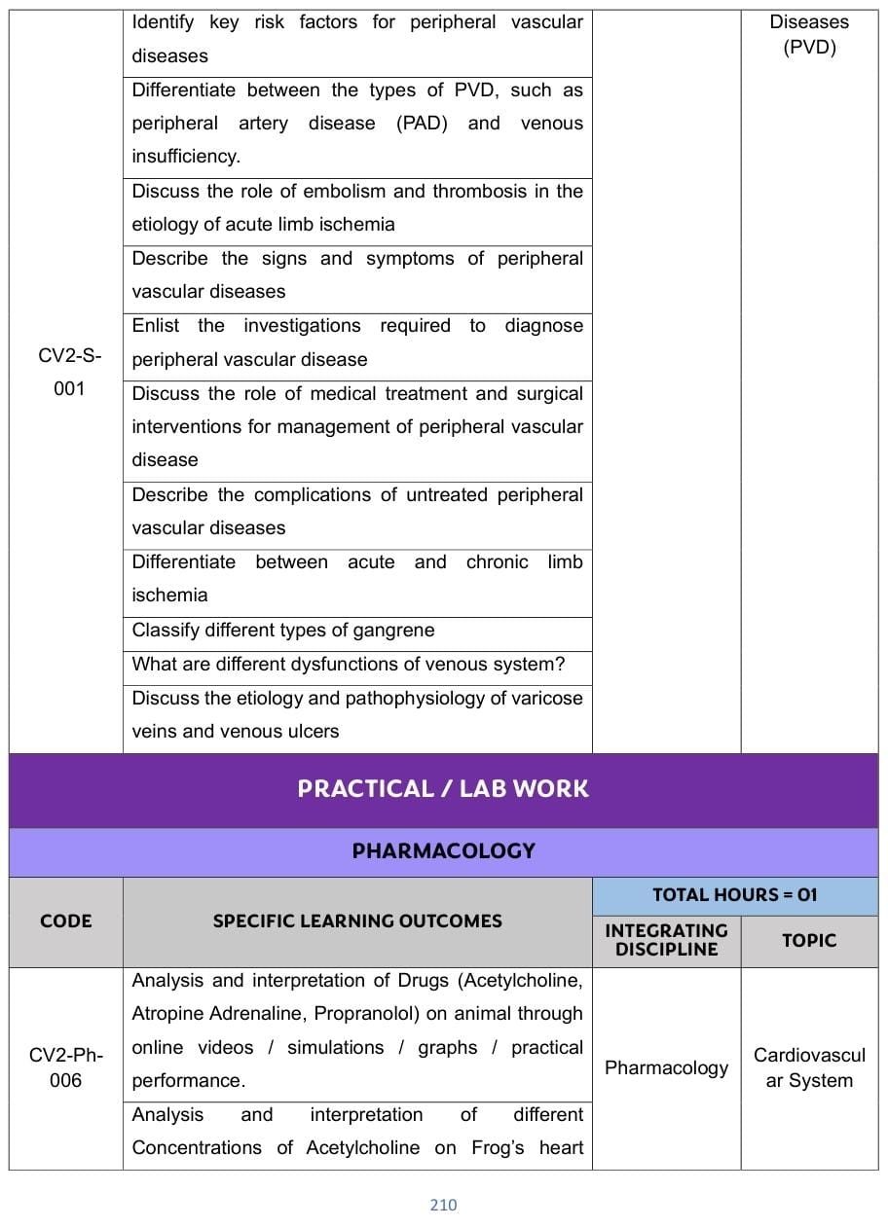
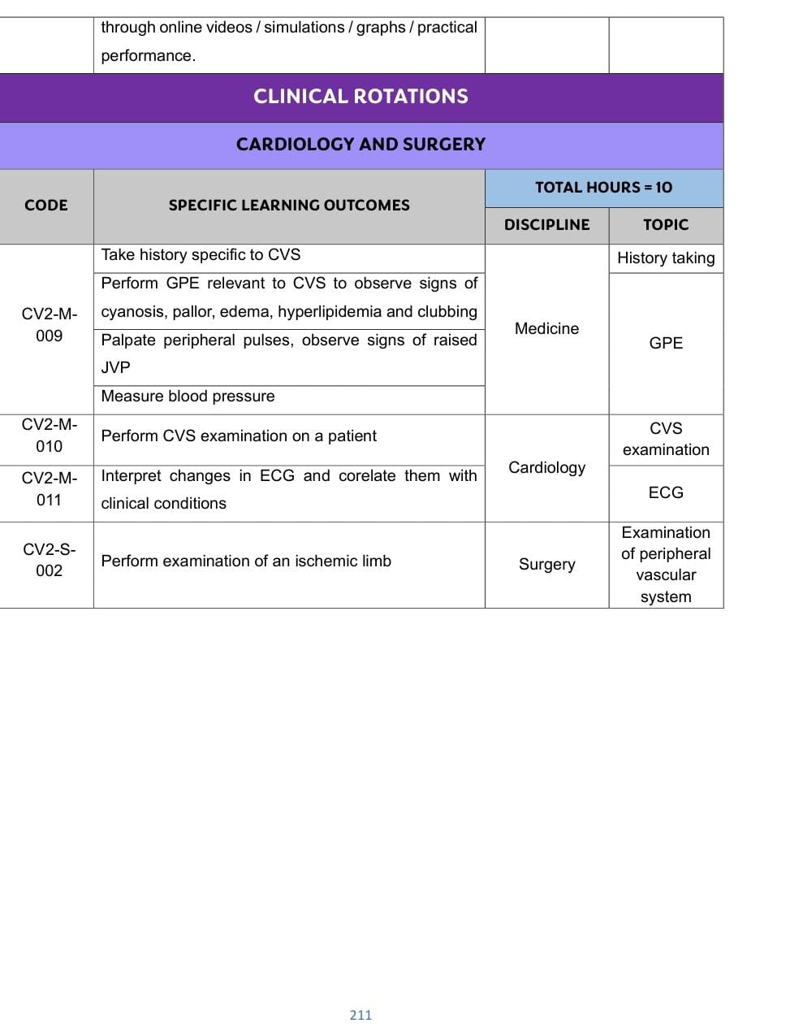

Respiratory System Module Content
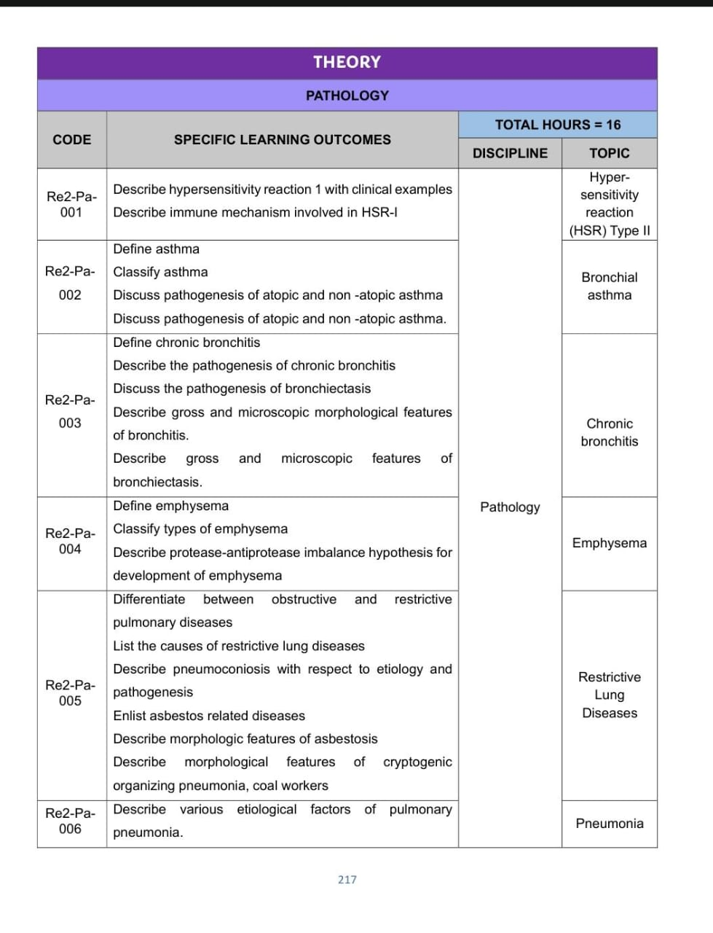
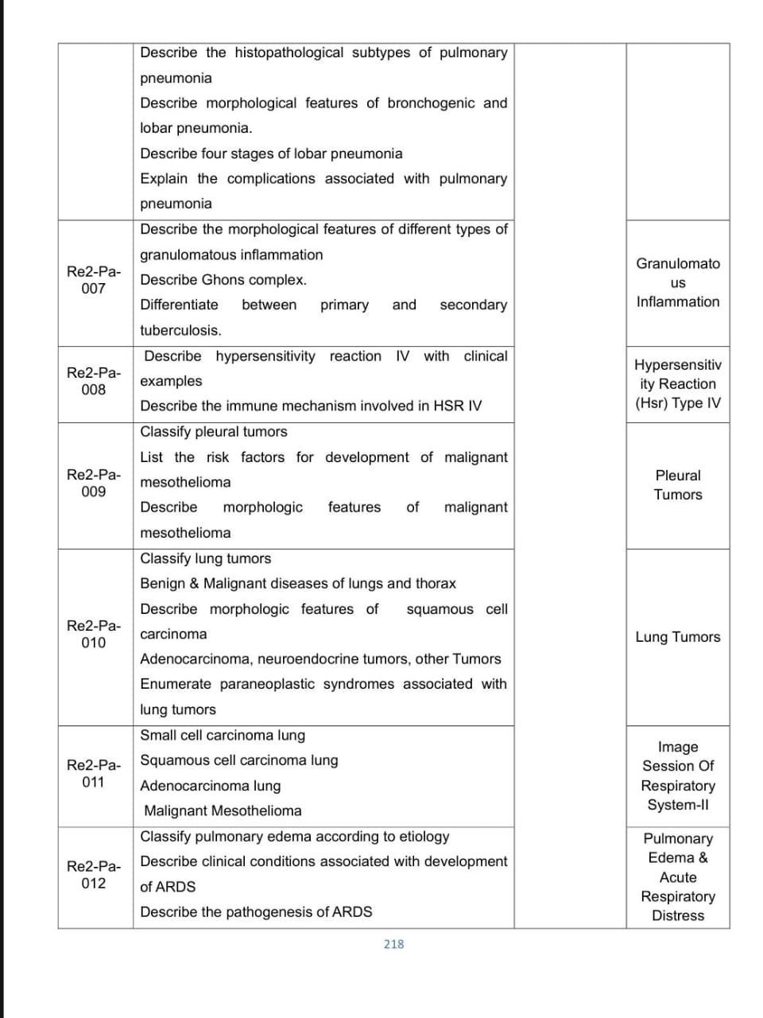
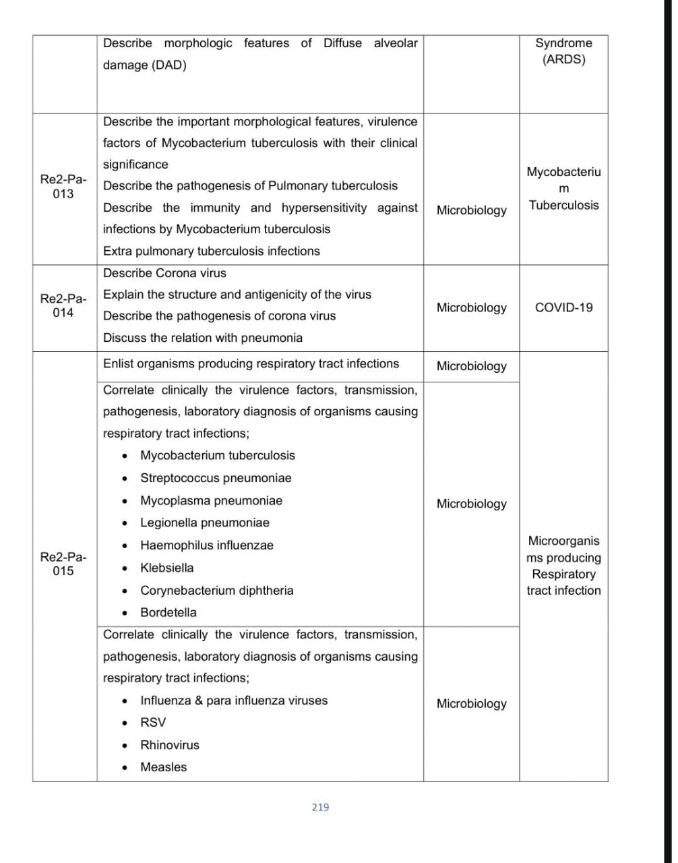
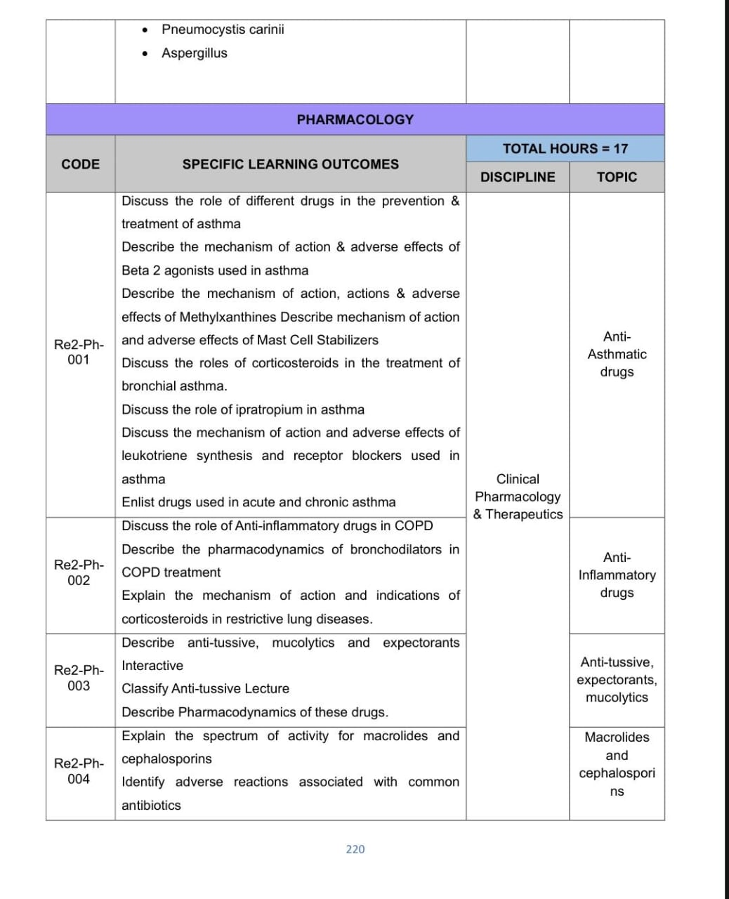
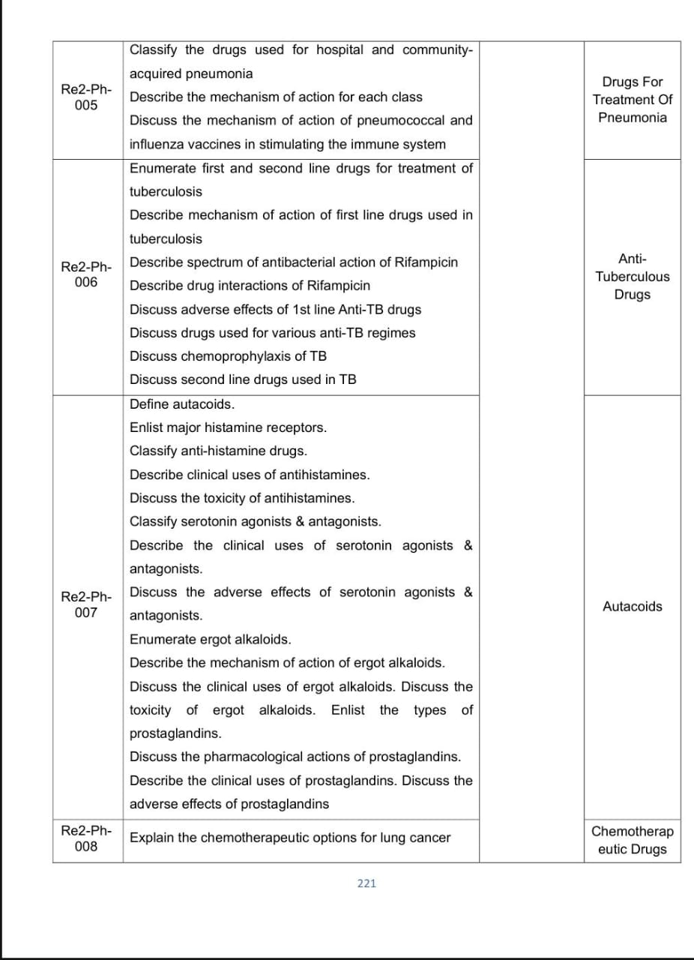
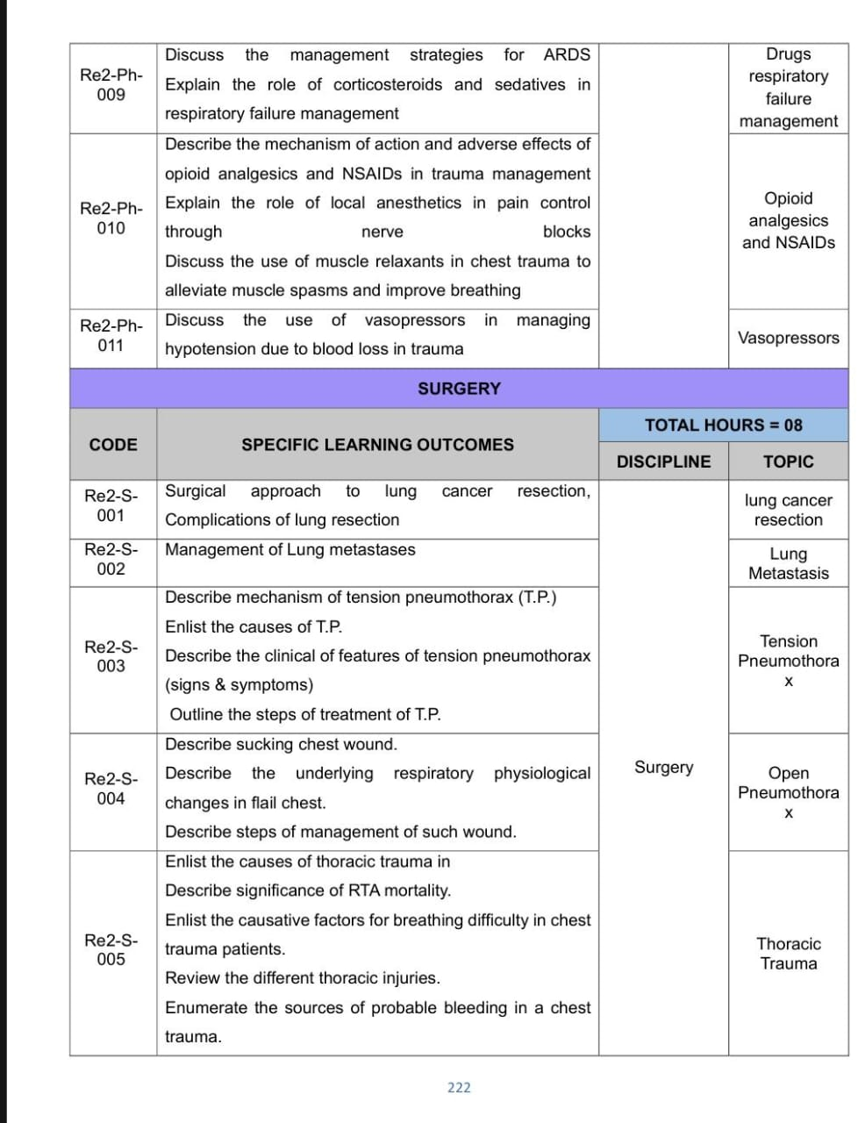
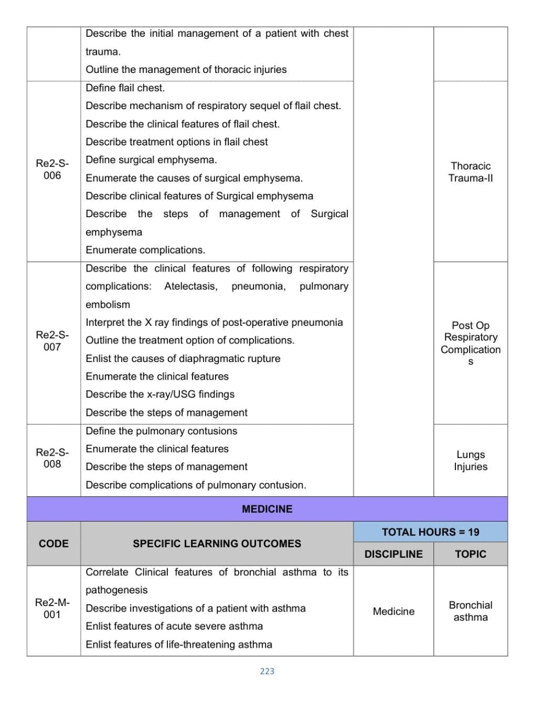
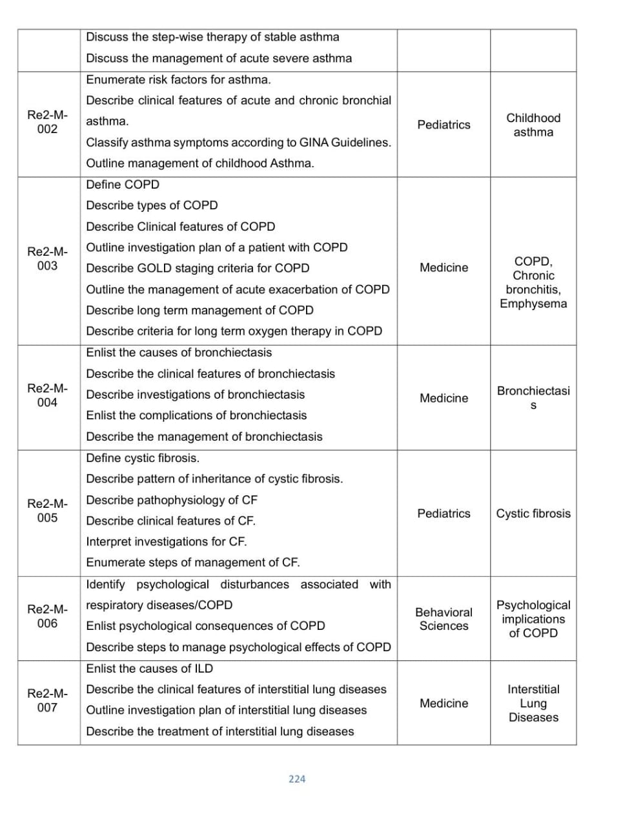
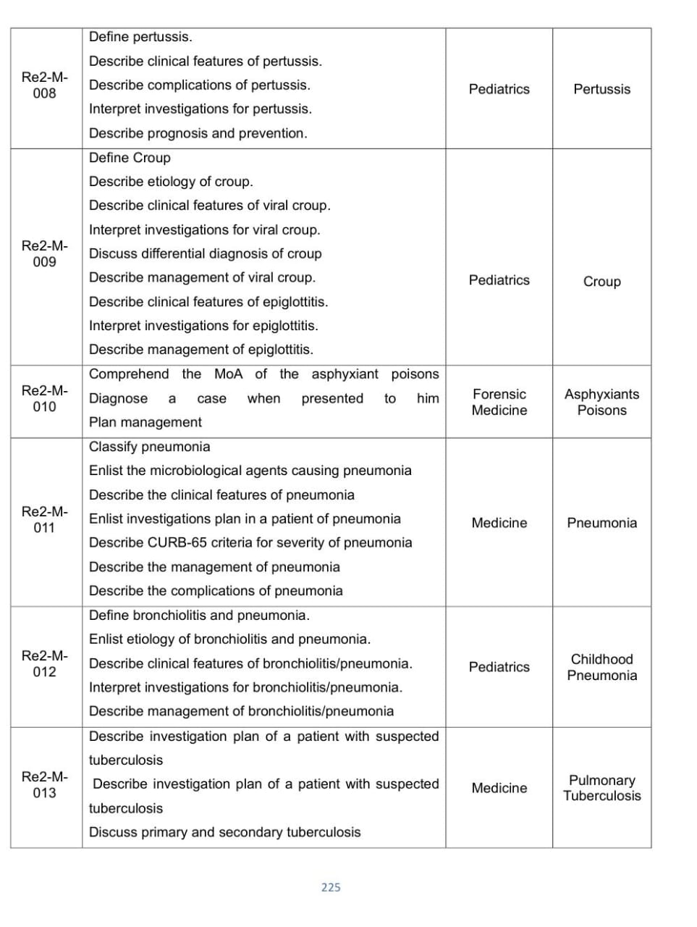
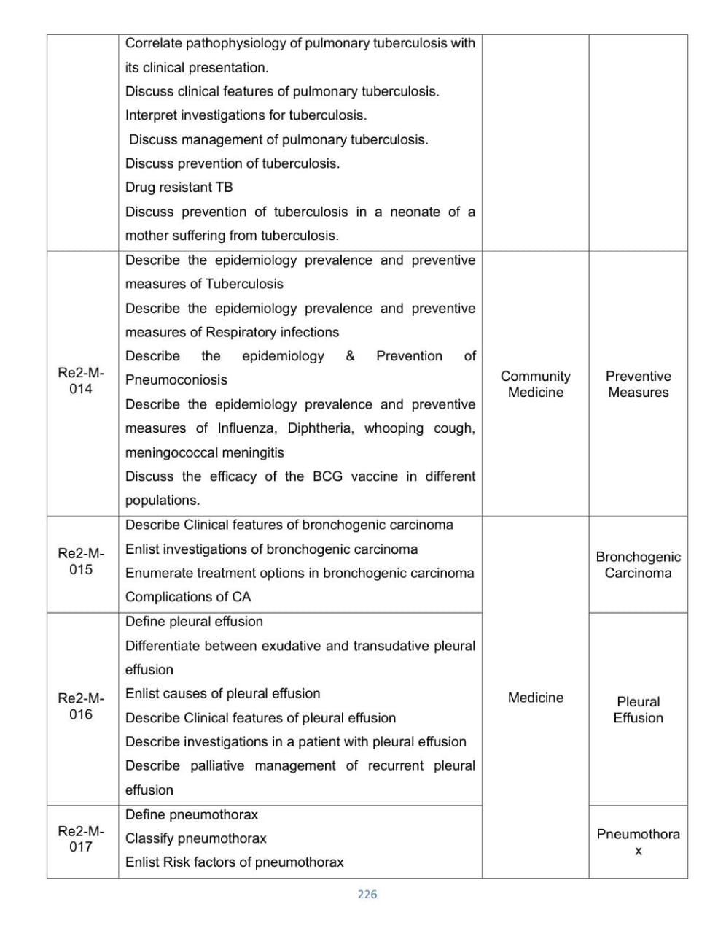
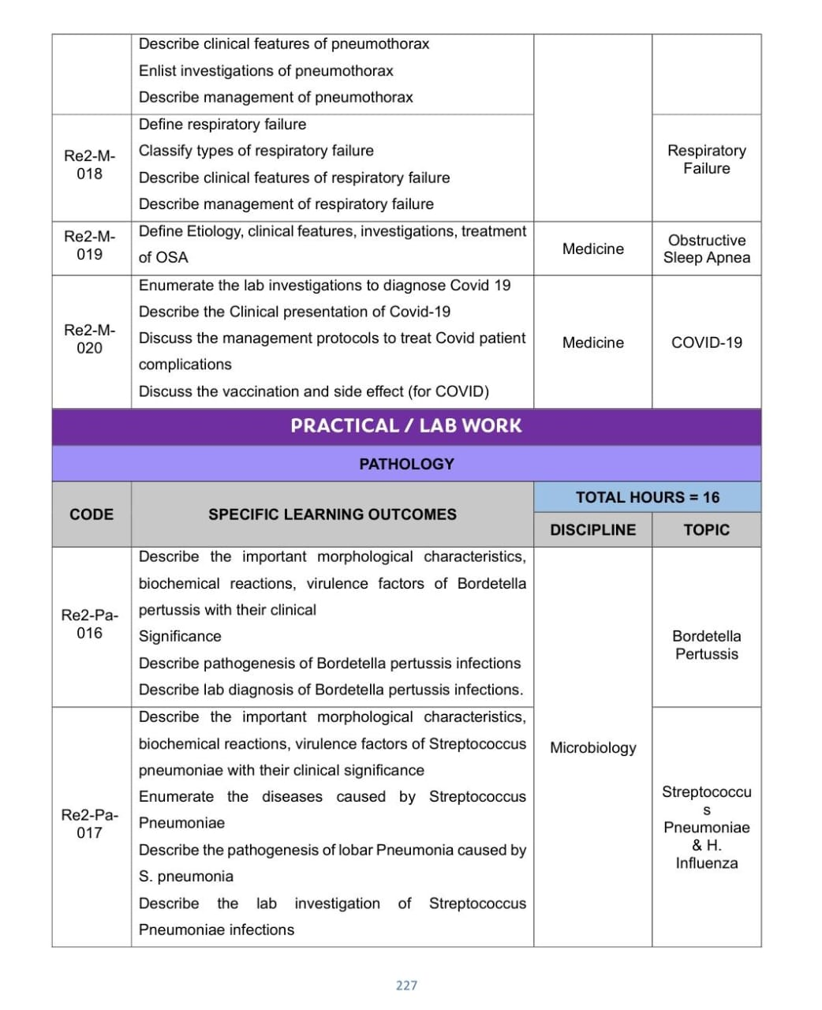
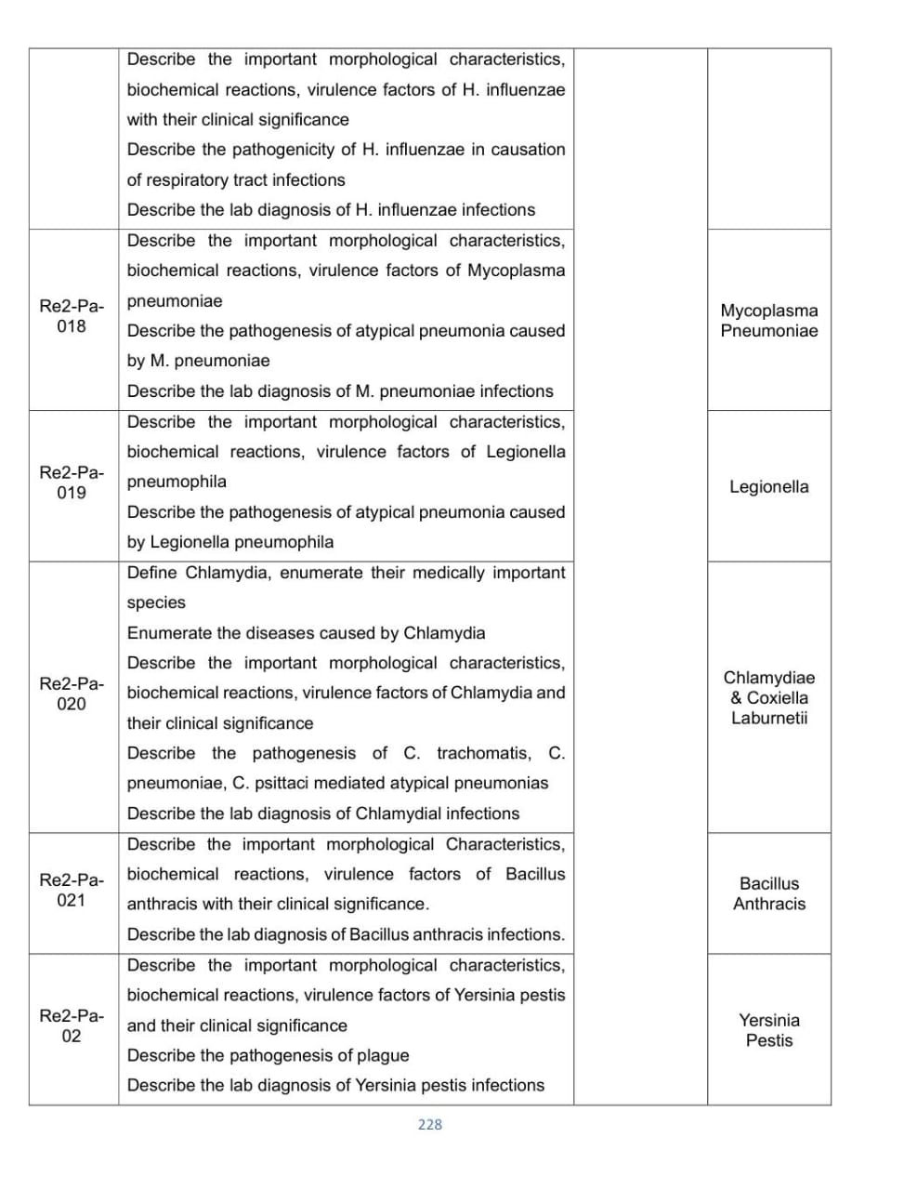
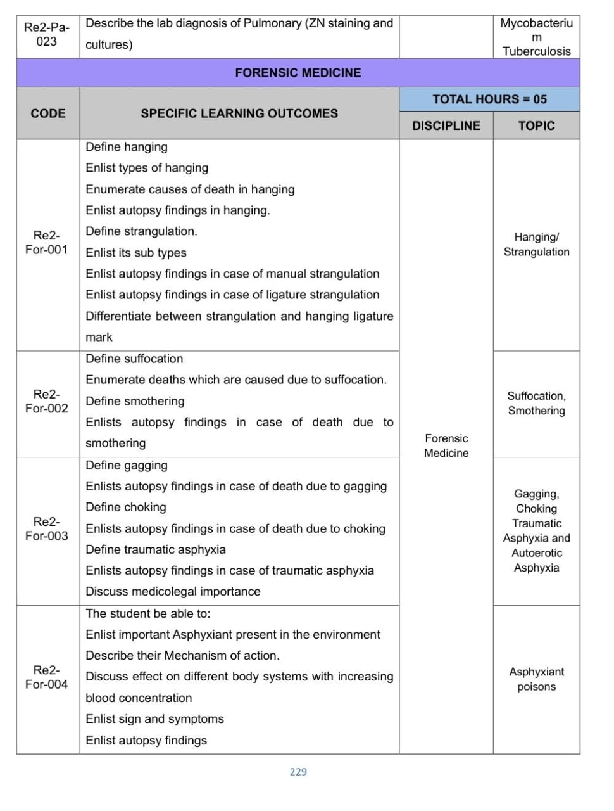
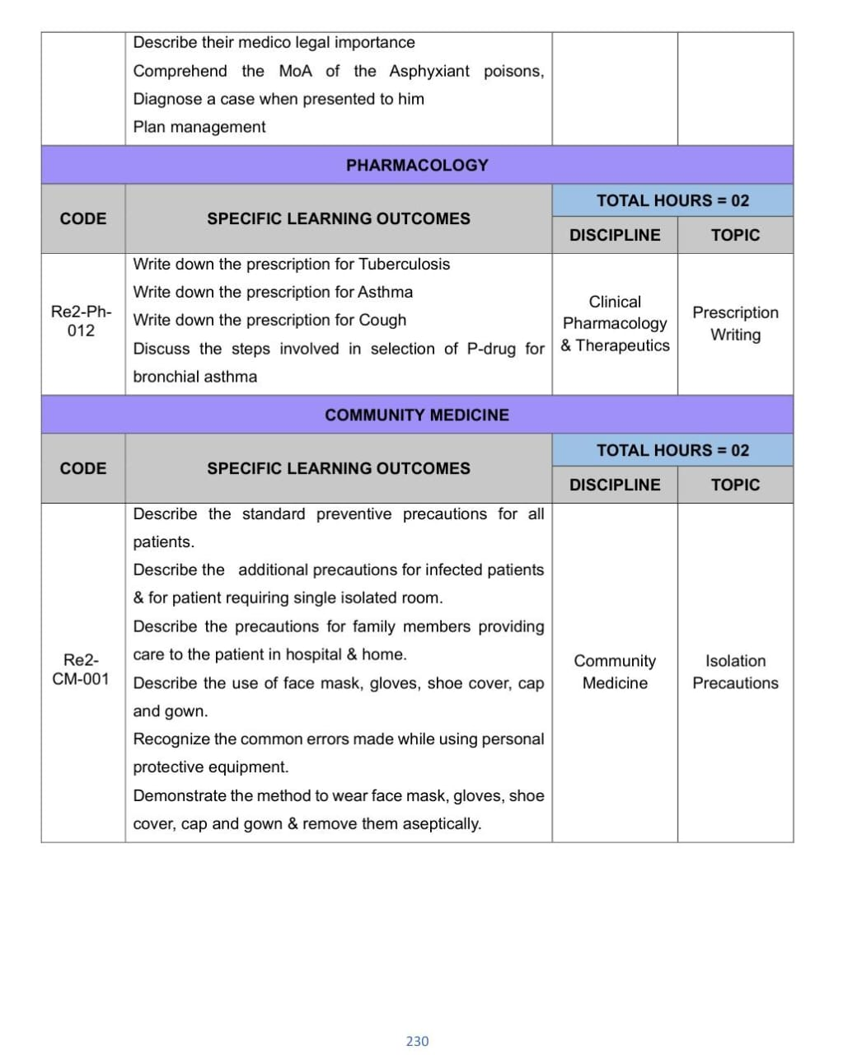
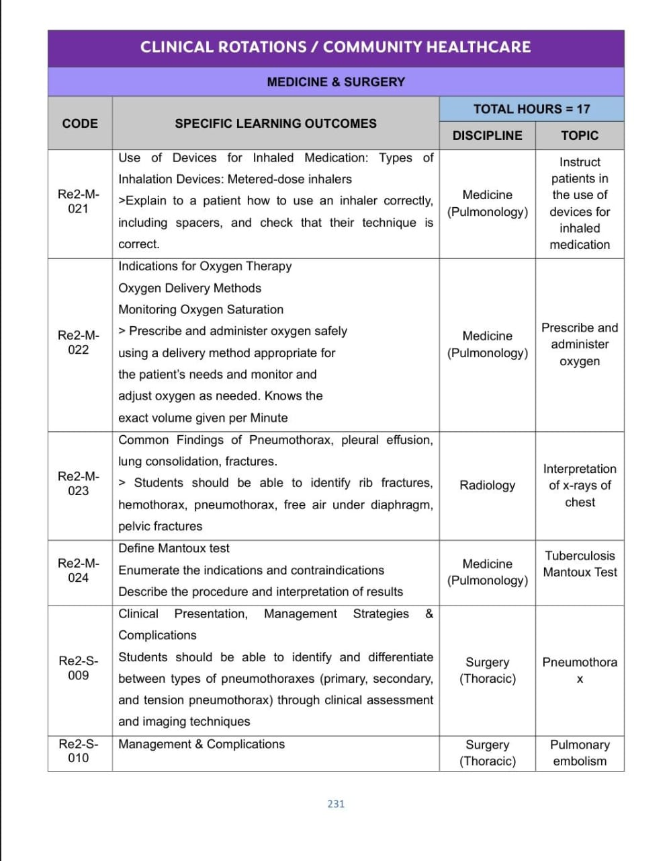
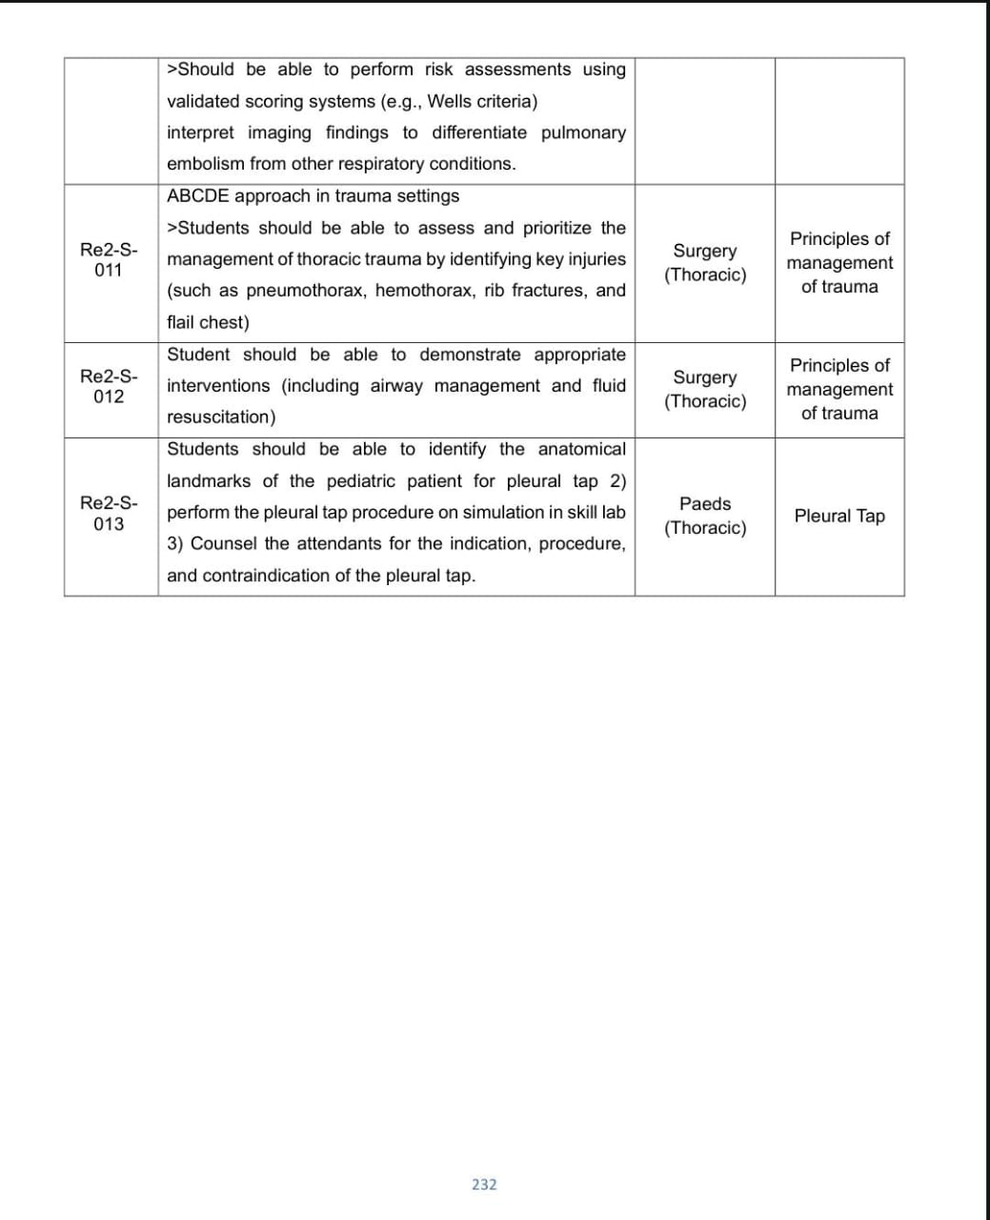
Community Medicine & Family Medicine Module Content
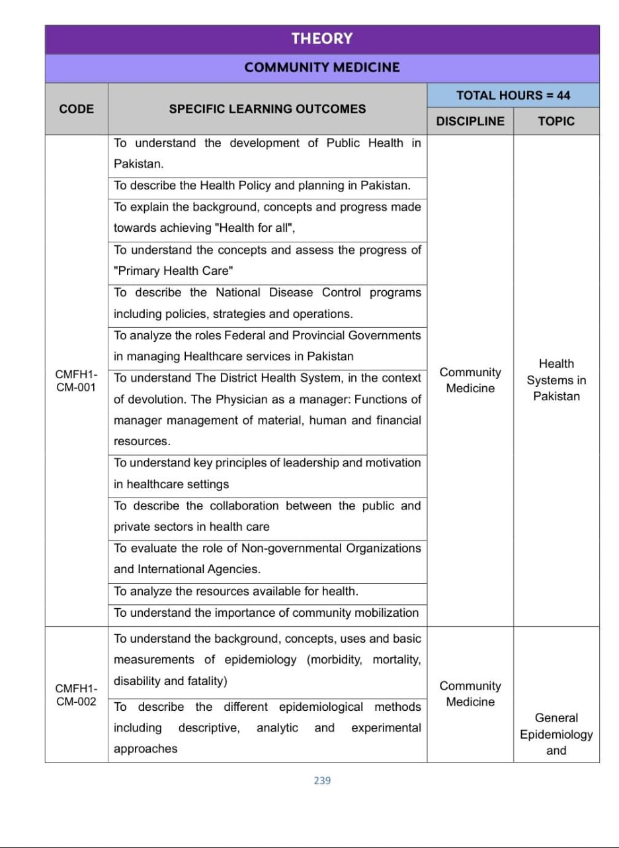
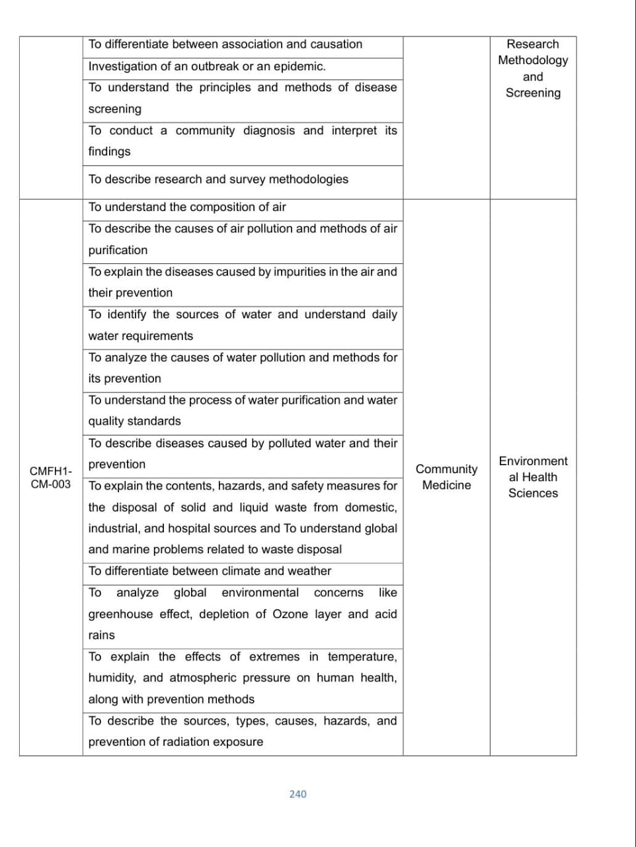
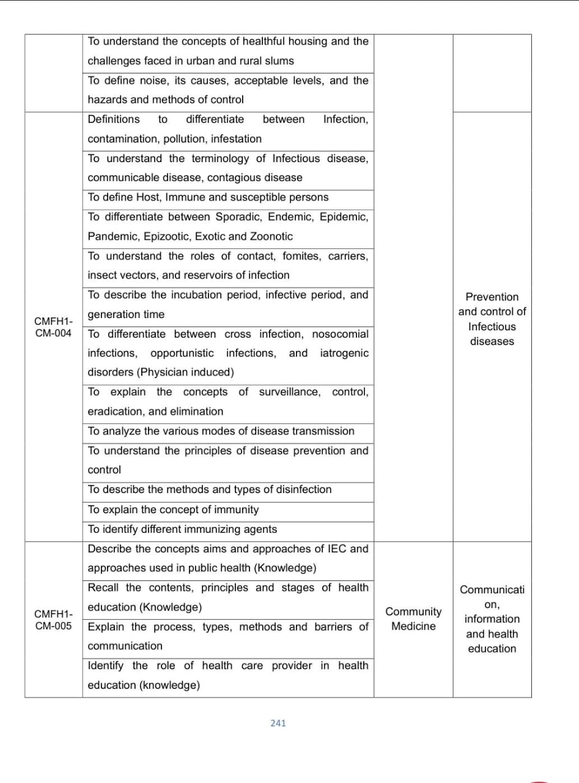
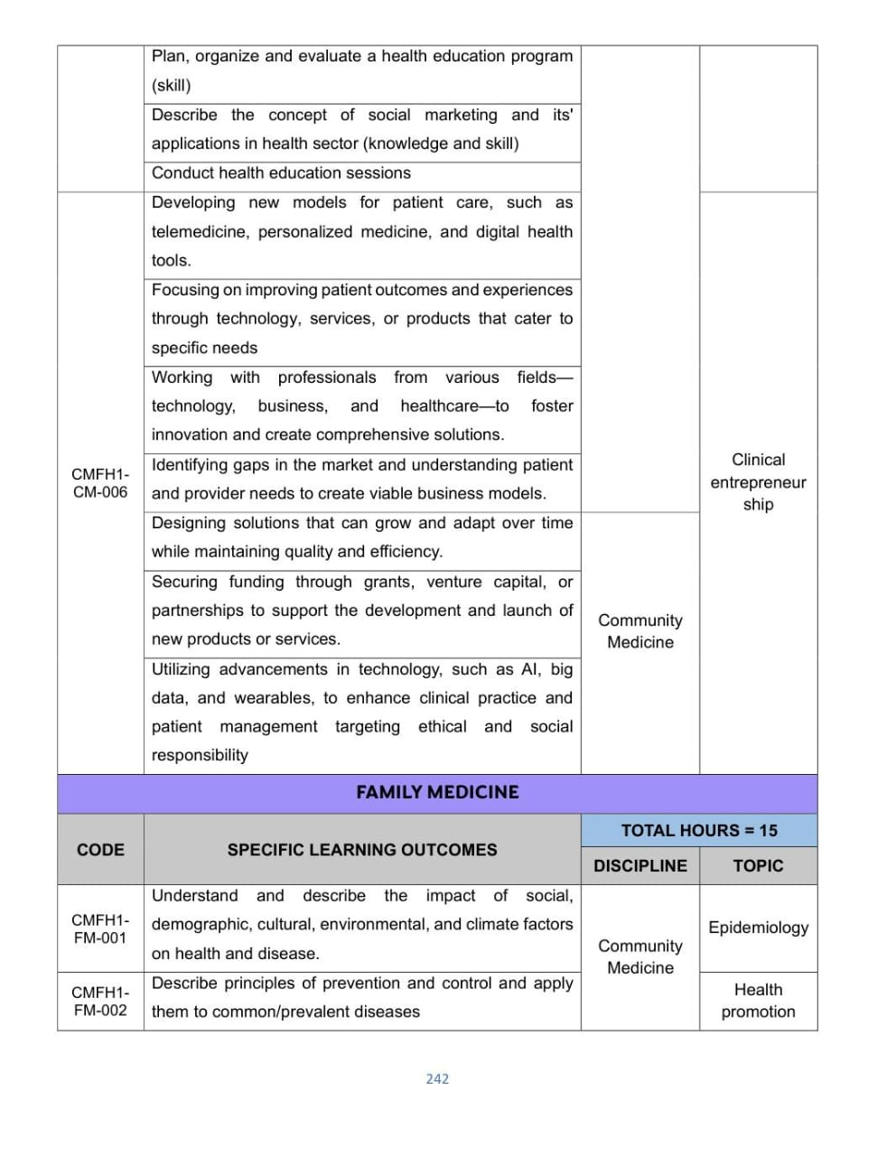
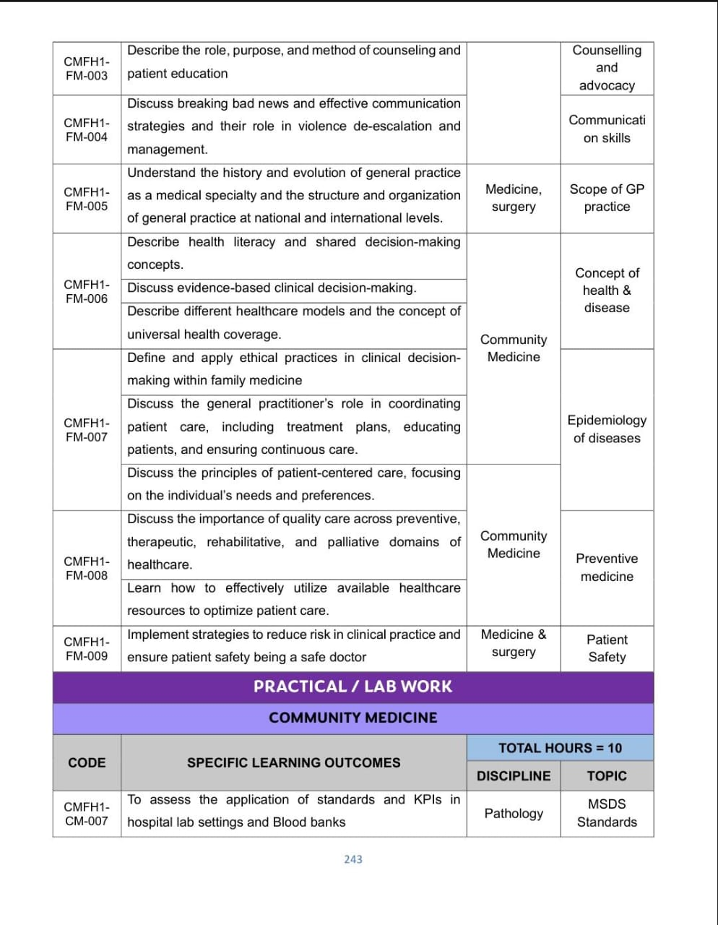
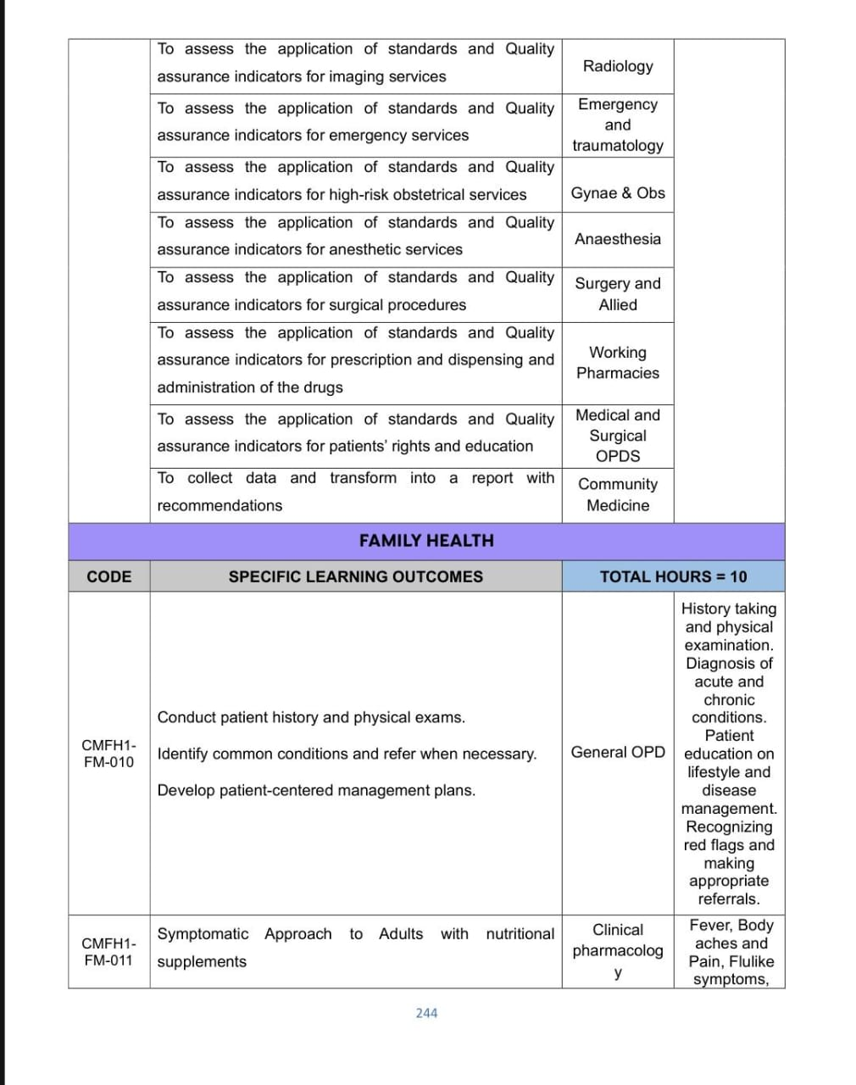
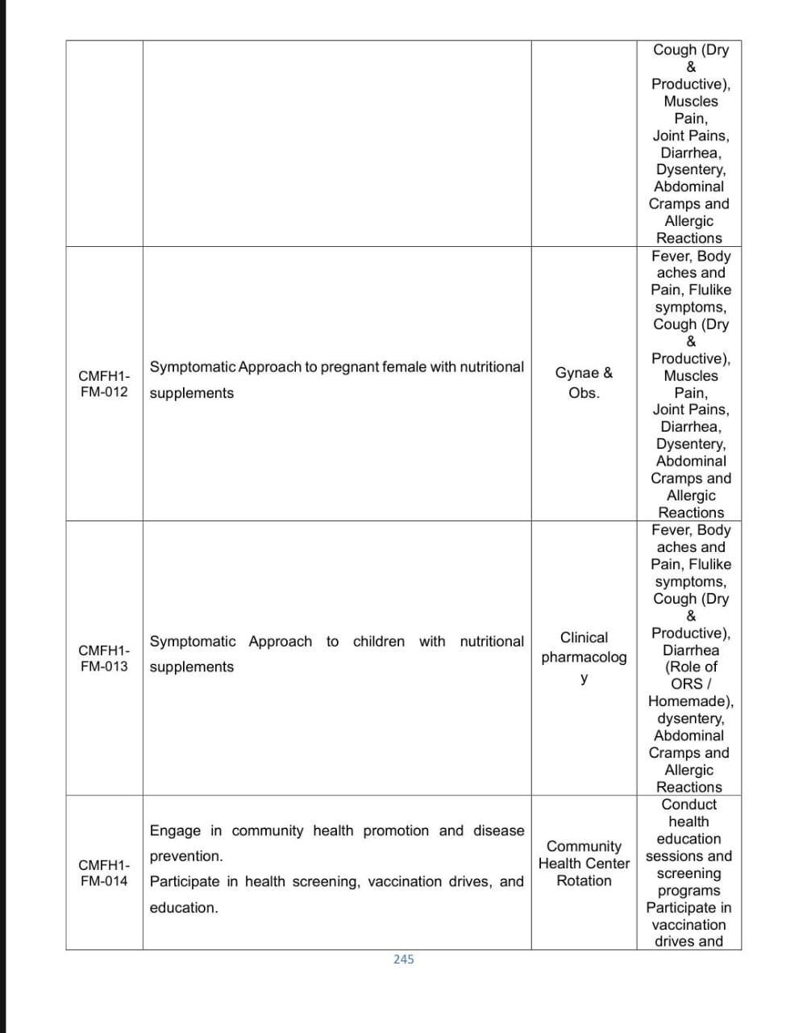
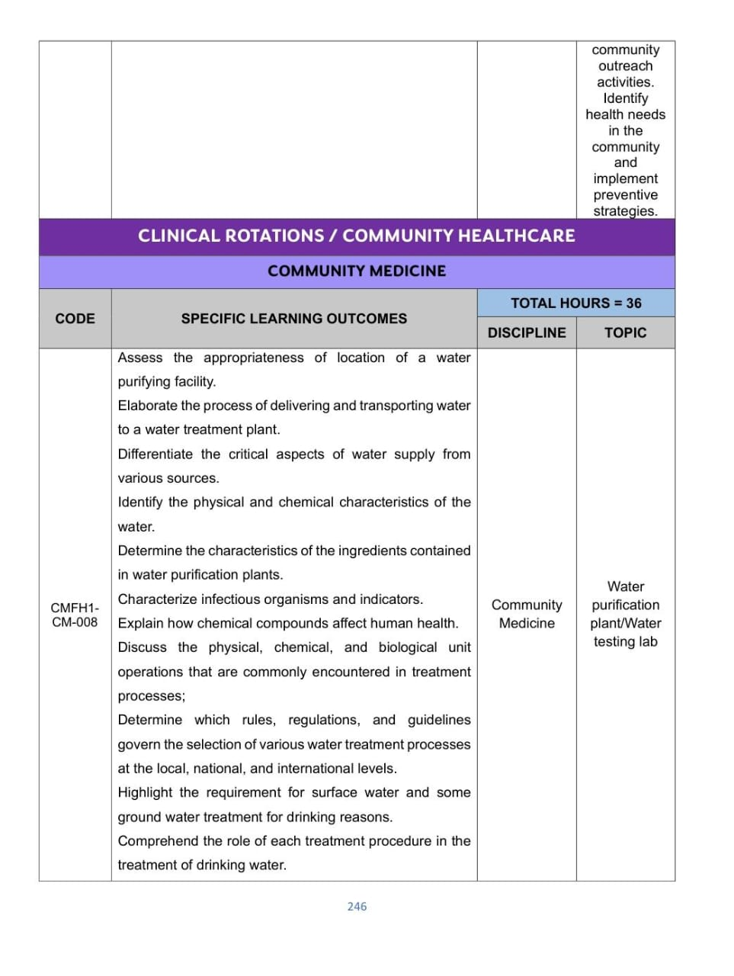
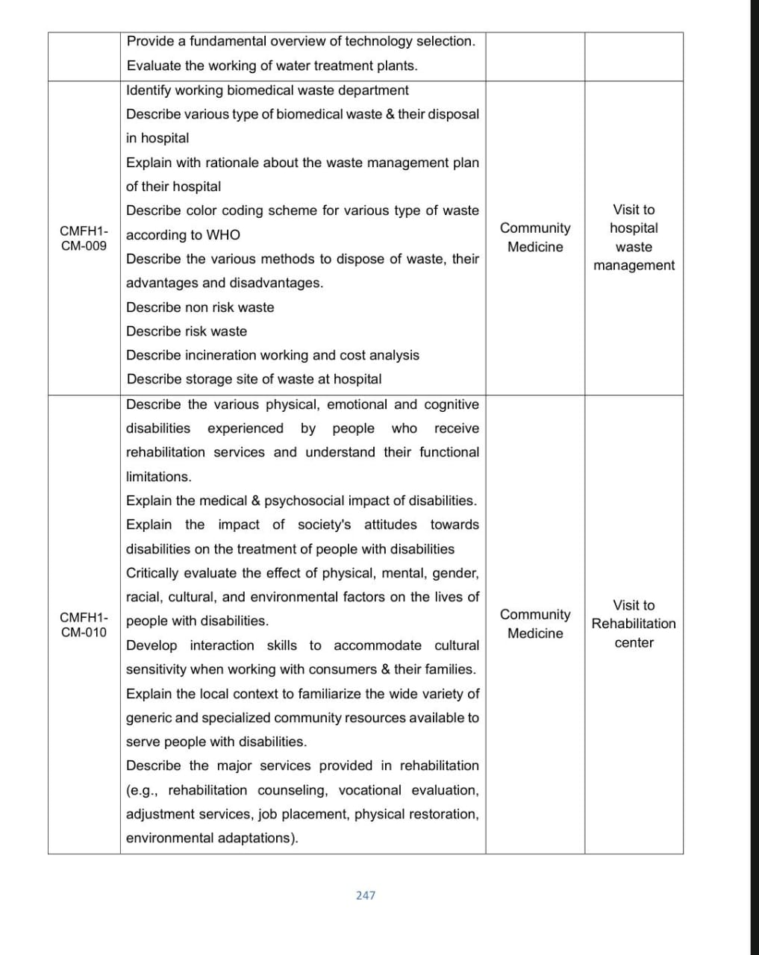
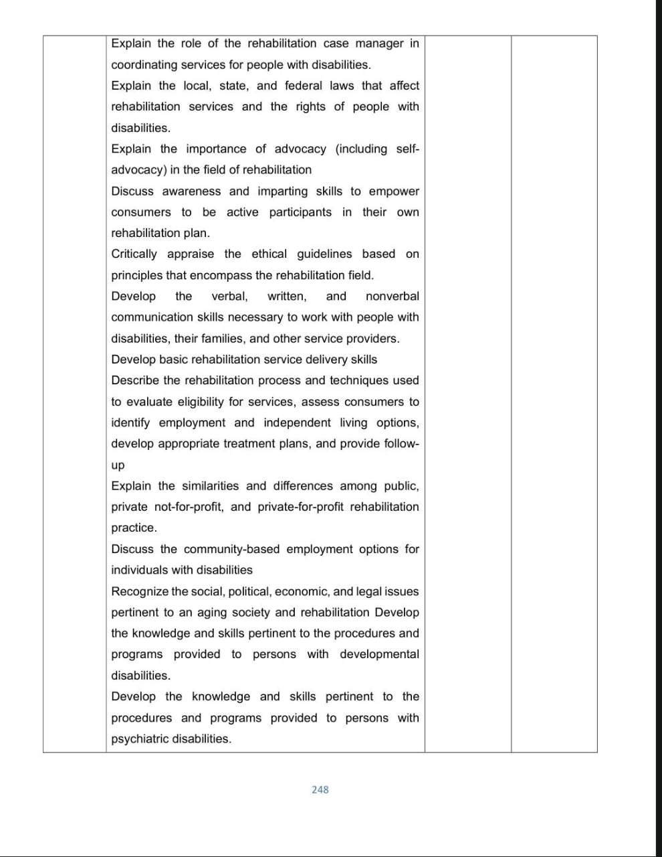
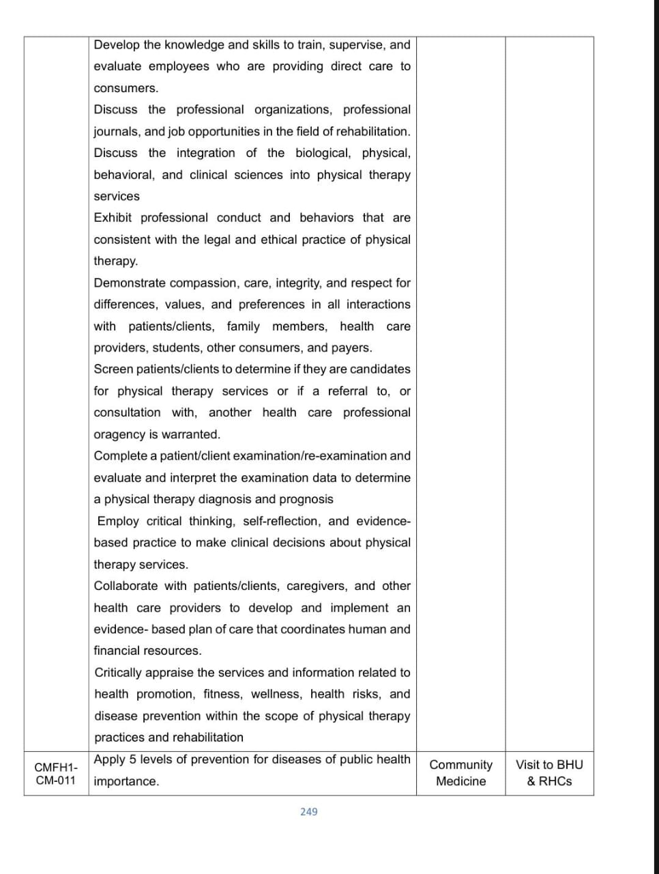
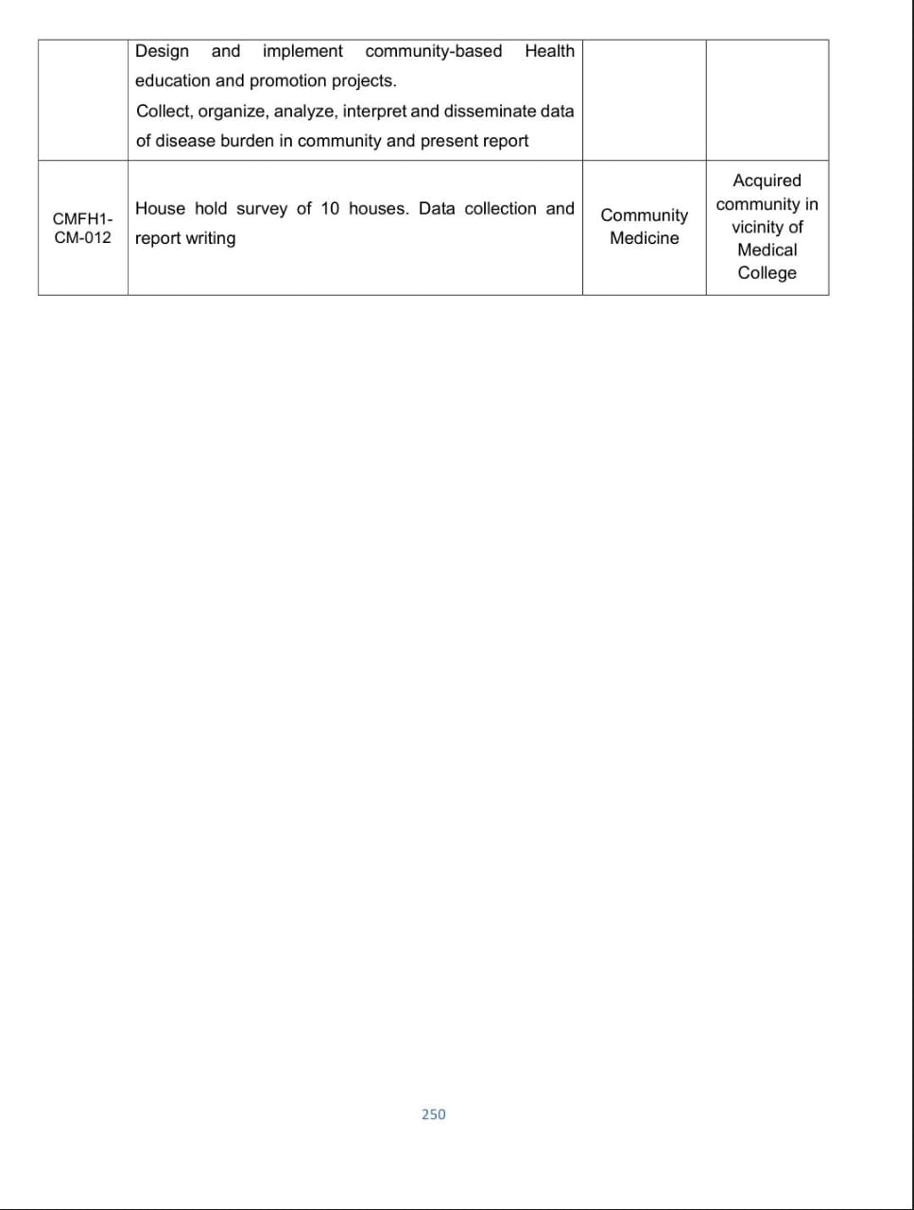
Forensic Medicine & Toxicology =III Module Content
